1) Which of the following conditions must be true so that a firm can price discriminate?
A) There are no other firms in the market.
B) The good is a non-durable.
C) The good cannot be easily resold.
D) All of the above.

2) At many municipal golf courses, local residents pay a lower fee to play than other golfers do. One necessary condition for the golf course to be able to successfully price discriminate according to residency is that
A) they can check the identification cards of golfers.
B) local resident golfers and other golfers have the same price elasticity of demand to play at the municipal course.
C) there are many golf courses nearby from which golfers can choose.
D) they require all golfers to rent a cart.

3) If consumers are identical, then
- price discrimination is impossible.
- price discrimination can occur if each consumer has a downward-sloping demand curve for the product.
- perfect price discrimination is the only form of price discrimination that can increase a monopoly's profit.
- tie-in sales cannot increase a monopoly's profit.

4) A perfect price discriminator
A) charges each buyer her reservation price.
B) charges different prices to each customer based upon different costs of delivery.
C) generates a deadweight loss to society.
D) charges lower prices to customers who buy greater quantities.

5) A perfect-price-discriminating monopoly's marginal revenue curve
- lies below the demand curve.
- is the demand curve.
- varies for each consumer.
- is the same as the monopolist's marginal revenue curve.

6) Which of the following sellers is most able to perfectly price discriminate?
A) a college or university
B) the post office
C) a clothing store
D) a grocery supermarket

7) The deadweight loss generated by a perfect-price-discriminating monopoly
A) equals the deadweight loss of a single-price monopoly.
B) is greater than the deadweight loss of a single-price monopoly.
C) equals zero.
D) equals the sum of all lost consumer surplus.

8) If a market is controlled by a perfect-price-discriminating monopoly, then
A) a deadweight loss is generated.
B) there is no consumer surplus.
C) consumer surplus is the same as under perfect competition.
D) output is less than that of a single-price monopoly.

Figure 12.1
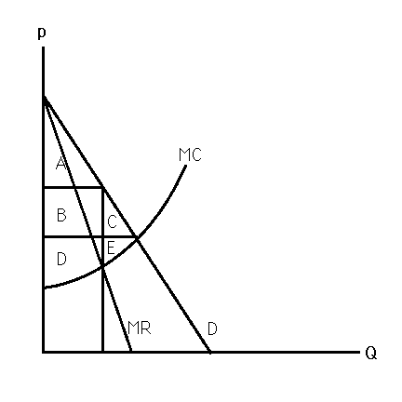
9) Figure 12.1 shows the market for a particular good. If the market is controlled by a perfect-price-discriminating monopoly, consumer surplus equals
A) A.
B) A + B + C.
C) C.
D) zero.

10) Figure 12.1 shows the market for a particular good. If the market is controlled by a perfect-price-discriminating monopoly, social welfare equals
A) A.
B) A + B + C.
C) A + B + C + D + E.
D) zero.

11) Figure 12.1 shows the market for a particular good. If the market is controlled by a perfect-price-discriminating monopoly, producer surplus equals
A) A + B + C + D + E.
B) D + E.
C) E.
D) zero.

12) Figure 12.1 shows the market for a particular good. If the market is controlled by a perfect-price-discriminating monopoly, the deadweight loss equals
A) C + E.
B) A + B + C.
C) C.
D) zero.

13) A monopoly will not be able to perfectly price discriminate if
A) obtaining information about each buyer's reservation price is too costly.
B) demand is very elastic.
C) demand is very inelastic.
D) resale is impossible.

14) A monopoly will not be able to perfectly price discriminate if
A) each consumer does not reveal her reservation price.
B) demand is very elastic.
C) the firm's marginal cost curve is upward sloping.
D) All of the above.

15) If a monopoly charges higher prices to consumers who buy smaller quantities than to consumers who buy larger quantities, then
A) consumer surplus is larger than under single-price monopoly.
B) social welfare is larger than under perfect competition.
C) the monopoly's profits are larger than under single-price monopoly.
D) the monopoly's profits are larger than under perfect price discrimination.

16) Quantity discrimination makes sense if
A) buyers of smaller quantities are more price sensitive than buyers of larger quantities.
B) buyers of smaller quantities are less price sensitive than buyers of larger quantities.
C) demand for the good is perfectly elastic.
D) the lower price for larger quantities encourages all consumers to purchase the larger quantity.
Figure 12.2
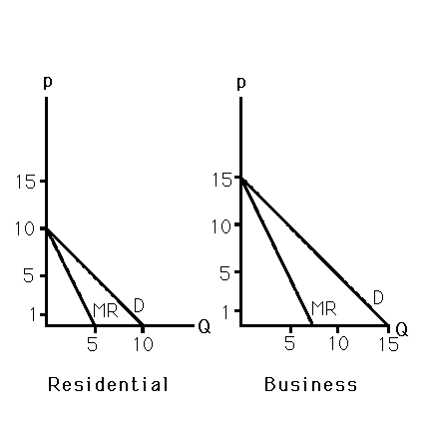
17) Bob is the only carpet installer in a small isolated town. Figure 12.2 shows the demand curves of two distinct groups of customers—residential and business. If the marginal cost of installing carpet is $1 per sq yard, what price does Bob charge each segment?
A) $1 in each market
B) $5.50 in the residential market and $8 in the business market
C) $1 in the residential market and $5 in the business market
D) $10 in the residential market and $15 in the business market

18) Bob is the only carpet installer in a small isolated town. Figure 12.2 shows the demand curves of two distinct groups of customers - residential and business. Bob is likely to price discriminate because
A) elasticities differ across markets.
B) the installation of carpets cannot be resold.
C) Bob can probably identify which consumers belong to which segment.
D) All of the above.

19) If two identifiable markets differ with respect to their price elasticity of demand and resale is impossible, a firm with market power will
A) set a higher price in the market that is more price elastic.
B) set a lower price in the market that is more price elastic.
C) set price so as to equate the elasticity of demand across markets.
D) set price equal to marginal cost in both markets.

20) A multimarket price discriminator sells its product in Florida for three times the price it sets in New York. Assuming the firm faces the same constant marginal cost in each market and the price elasticity of demand in New York is -2.0, the demand in Florida
A) has an elasticity of -6.0.
B) is more price elastic than the demand in New York.
C) has an elasticity of -1.2.
D) has an elasticity of -0.67.

